**Architecture Document**

S3-CB04

Web Shop – “**S. H. A. I. N.”**



**Name :** Shanessa Kostaman (450080)

**Student Number :** 4082419

**Email :** genoveva.shanessakostaman@student.fontys.nl

**Teachers :**

Jacco Snoeren – [j.snoeren@fontys.nl](mailto:j.snoeren@fontys.nl)

Onno Marsman – [o.marsman@fontys.nl](mailto:o.marsman@fontys.nl)

**Fontys University of Applied Sciences**

**Eindhoven – Netherlands**

**2020-2021**

Table of Contents

SOLID Guaranteed 3

C4 Architecture Diagram 4

C1 Diagram 4

C2 Diagram 5

C3 Diagram 6

(Part 1) 6

(Part 2) 7

C4 Diagram 8

Design Decisions 9

1. Autoconfiguration 9

2. Opinionated approach 9

3. Standalone applications 9

# SOLID Guaranteed

In this project I’m going to implement SOLID Principals, as we can see from the UML Diagram (C4 Diagram).

I’m going to focus on implementing Dependency Injection (D from SOLID) and I’m going to use it on the unit testing. Because on this semester we’re learning about Dependency Injection.

# C4 Architecture Diagram

## C1 Diagram

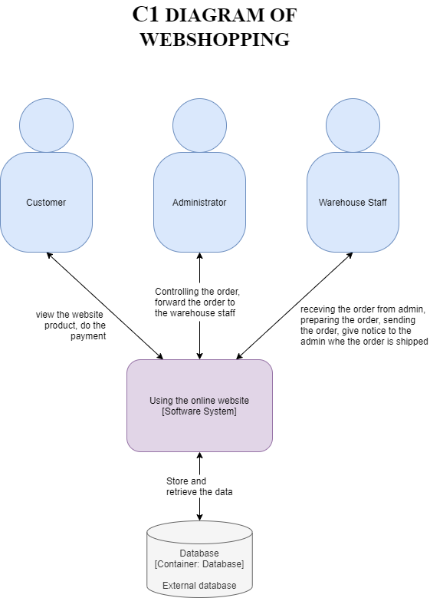

## C2 Diagram

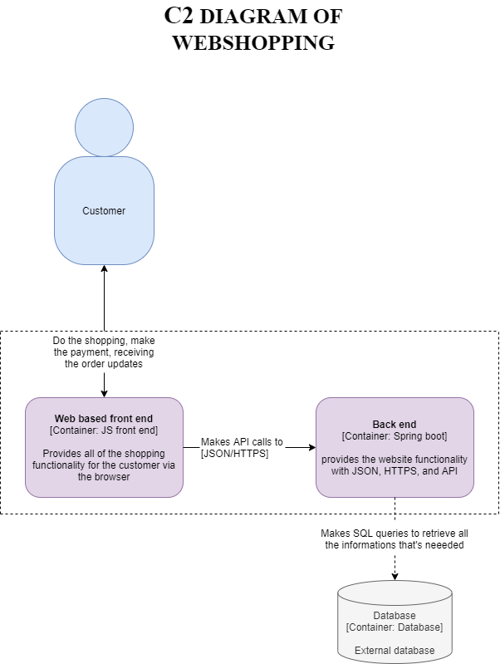

## C3 Diagram

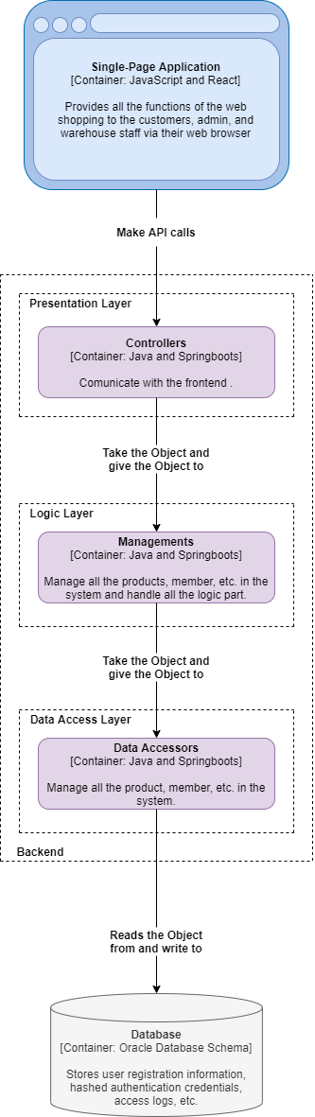

# C4 Diagram

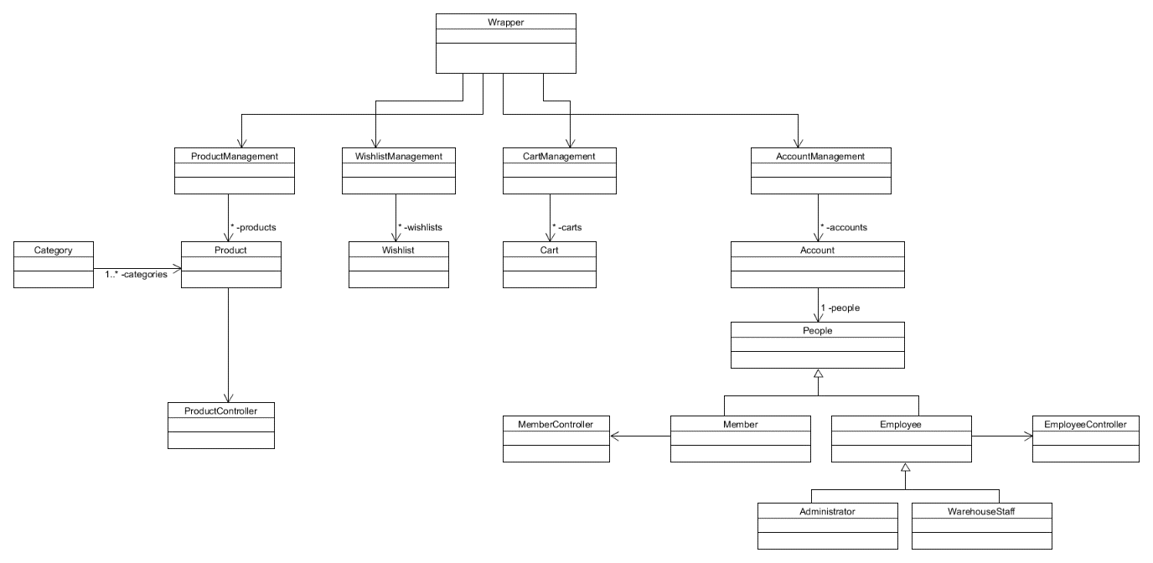

## Design Decisions

Reason why I’m using spring boots. The first reason I’m using the spring boots is because it’s mandatory to use spring boots in this semester, but there’s other reason why I’m using spring boots. Because on this semester we learn about Dependency Injection from SOLID, Spring boots help us with dependencies and Spring boots also help us to developing web application with the spring framework faster and easier. There’s 3 core capabilities from Spring boots:

## Autoconfiguration

Autoconfiguration means that we don’t have to configure manually because the applications are initialized with pre-set dependencies. As Java Spring Boot comes with built-in autoconfiguration capabilities, it automatically configures both the underlying Spring Framework and third-party packages based on your settings (and based on best practices, which helps avoid errors). Even though you can override these defaults once the initialization is complete, Java Spring Boot's autoconfiguration feature enables you to start developing your Spring-based applications fast and reduces the possibility of human errors.

## Opinionated approach

For adding and configuring starter dependencies based on the needs of your project, Spring Boot uses an opinionated approach. rather than requiring you to make all those decisions yourself and set up everything manually, Spring Boot chooses which packages to install and which default values to use.

## Standalone applications

We don’t need to relying on an external web server to run our app during the initialization process, because Spring boots help our application to run on their own.